The AllegroU AddOn represents tools that can be added to Allegro 8 to provide easy access to knowledge to the user, directly from the application.

* The AddOn tools should display as a menu item that appears in the Ribbon on every view in Allegro
* The **AllegroU** menu item will contain the following 3 function icons (Marketing will eventually provide a suitable icon for the button and the displayed name of the button may change.)
  1. Video Capture
     + This button will launch the Qumu video capture tool
  2. Video Help
     + Will display a list of business processes, reflective of the view the user is on.
     + For the key business processes, those processes will have a link to AllegroU that provides a short video of the process being demonstrated
     + The cross reference of business processes to videos will be editable such that the user can replace any Allegro supplied video for their own custom videos (on AllegroU)
  3. Search
     + The search tool will allow the user, from the Application, to simultaneously search AllegroU as well as the Allegro Knowledge base.
     + The resulting results set will be displayed
     + The user can click to access the search result (connecting to either AllegroU or the Knowledge Base)

**New menu item in the Ribbon**

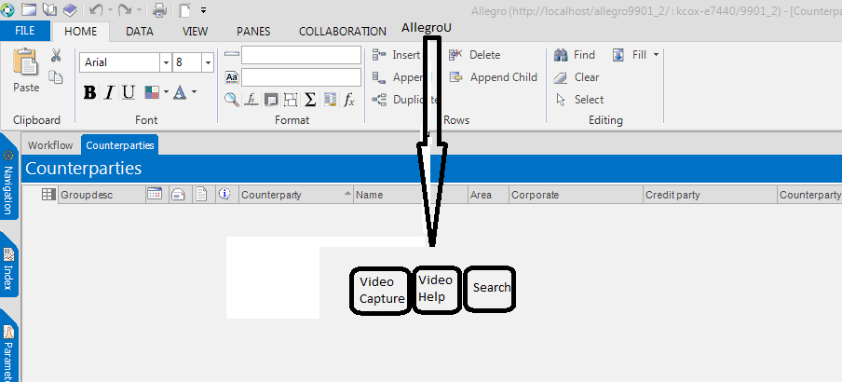

**Additional Details on the Video Help tool**

The purpose of this tool is to provide the user with quick and easy access to video based instruction on how to complete a task (business process).

* The Allegro Business Process model, an existing series of metadata tables, will be used to store the URL to a representative video.

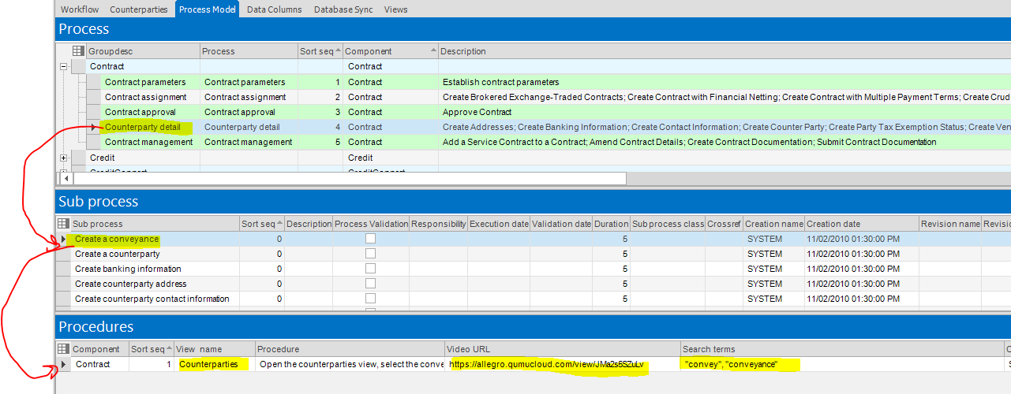

* Suggested columns added to the Procedures table (sequences 20 and 21)

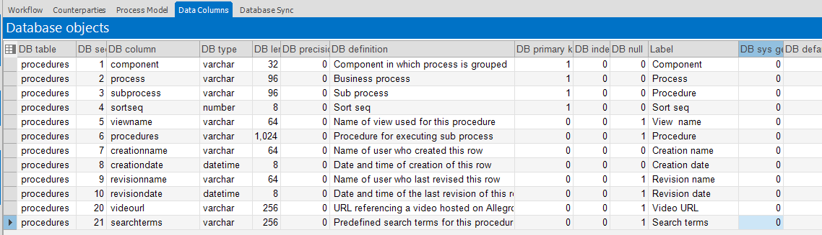

* When the user clicks **Video Help** from a view, the extension should know the view the user is currently on – and issue a SQL statement to bring back all Procedure rows referencing that viewname. For example, assuming the user is on the Counterparties view – the SQL might look like this:

select distinct subprocess.subprocess, procedures.videourl, subprocess.sortseq

from process, subprocess, procedures

where process.process = subprocess.process

and subprocess.process = procedures.process

and subprocess.subprocess = procedures.subprocess

and procedures.viewname = 'Counterparties'

and procedures.videourl is not null

order by subprocess.sortseq

* The resulting rows should be displayed the user in a browser window, with the ability to click/double click on the applicable video to play.



**Additional Details on the Search Tool**

The purpose of this tool is to provide a consolidated search into two of the primary knowledge tools available to users. AllegroU and the Allegro Knowledge base. This tool levereages a “searchterm” column add to the Process model metadata. That field will contain a starting set of search terms – however at the time of the search, the user should be able to augment further.



When the user clicks the Search button…

* A browser appears with all pre-defined search terms applicable to the view the user is on. Sample SQL

select distinct subprocess.subprocess, searchterms, subprocess.sortseq

from process, subprocess, procedures

where process.process = subprocess.process

and subprocess.process = procedures.process

and subprocess.subprocess = procedures.subprocess

and procedures.viewname = 'Counterparties'

and procedures.videourl is not null

order by subprocess.sortseq

* Representative result.  
  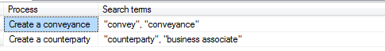
* The user should be able to augment the search terms, if desired
* Then press some key / double click…something to trigger the search, for these keywords, in AllegroU and the Knowledge Base
* The resulting hits would be merged, with links to each “hit” available such that the user can quickly launch the search result in its respective source (AllegroU or the KB)
* Note – the Knowledge base is a .net / Web Services based platform that is hosted inside Allegro’s firewall, but provided by vendor Phaseware.

Sample display from the Knowledge base and AllegroU

